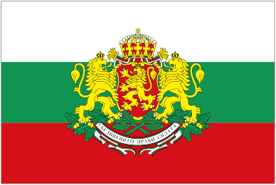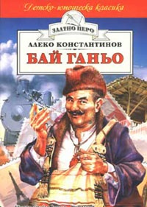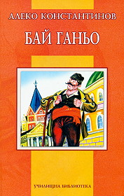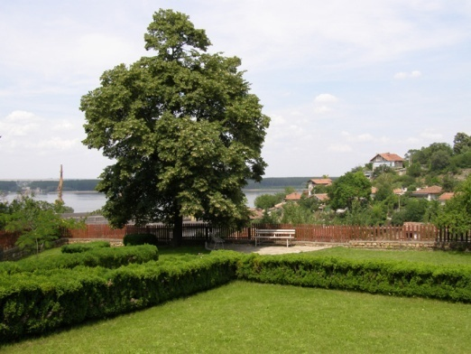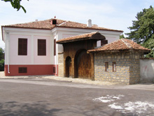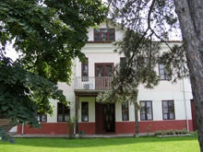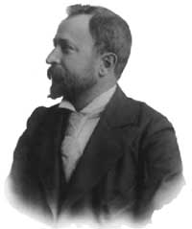

BULGARIA

**Aleko Konstantinov** / January 1863 - 11 May 1897/ was a Bulgarian writer, best known for his character Bay Ganyo, one of the most popular characters in Bulgarian fiction.

Born to an affluent trader in the Danube River town of [Svishtov](http://en.wikipedia.org/wiki/Svishtov), he attended the Faculty of Law of the University of Odessa, graduating in 1885. He worked as a jurist in Sofia before embarking on a writing career. His first novel (in fact, a collection of relatively independent short stories), *Bay Ganyo* ("Uncle Ganyo"), describes the travels through Western Europe of an itinerant peddler of rose oil and rugs. Though impertinent and clumsy, the nevertheless ingenious Bay Ganyo has been seen as a mirror for a modernizing Bulgaria. At the beginning of the novel Bay Ganyo is seen mainly as trading rose oil while at the end he is portrayed as a political man. His prototype is the [Karlovo](http://en.wikipedia.org/wiki/Karlovo) tradesman Ganyo Somov.

Konstantinov, a cosmopolitan traveler, was the first Bulgarian to write about his visits to Western Europe and America. His visits to the World Exhibitions in Paris in 1889, Prague in 1891 and Chicago in 1893 provided Bulgarian readers, who had recently gained independence from nearly 500 years of Turkish Ottoman oppression, with a portrait of the developed world. *To Chicago and Back* (where Bay Ganyo appears once again, but only as a third plan person), his travel notes from his American trip, spurred a lasting interest in Chicago, which today boasts the largest concentration of Bulgarian immigrants in the United States. Nowadays there's a bust of the writer in the University of Chicago's Regenstein Library.

Aleko Konstantinov initiated the tourist movement in Bulgaria. This is why two of [Vitosha](http://en.wikipedia.org/wiki/Vitosha)'s hotels are named after him - "Aleko" and "Shtastlivetsa" ("The Lucky Man", the nickname he gave to himself in one of his short stories).

Konstantinov is portrayed on the obverse of the Bulgarian 100 [levs](http://en.wikipedia.org/wiki/Bulgarian_lev) banknote, issued in 2003.

Museum Aleko Konstantinov in Svishtov city