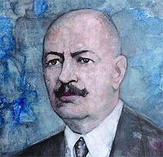
BULGARIA

Dr. Stamen Grigorov was born on October 27, 1878 in the village of Studen Izvor, Tran Region, Bulgaria. He graduates secondary education in natural sciences in Montpellier, France and medical science in Geneva, Switzerland. As a scientist in the field of microbiology, dr. Stamen Grigorov is famous first of all that in 1905, at the age of 27, in the laboratory of Professor Masole in Geneva, he invented the bacillus that is crucial element of the yogurt, called by the scientific community "Bacterium bulgaricum - Grigorov", thus making his contribution to
the world microbiology.
His further research, carried out in many research institutes worldwide proved that Bulgarian yogurt helps in the treatment of various diseases and affections like infections, otic-rhino-laryngeal diseases tuberculosis, stomach and intestine affections, ulcers, some gynecologic diseases, fatigue, etc. These prophylactic and curing properties of Bulgarian yogurt are due to the highly rich content of vitamins B1, B2, C, A, D, E, PP, B12, milk sugar, proteins, and other important
stimulating substances.
The yogurt of its original kind can be leavened only in Bulgaria and in some neighbor regions in the Balkan countries. In order geographic conditions the bacteria degenerate quickly, lose their qualities and die.
Besides the invention of "Bacterium bulgaricum", Dr. Stamen Grigorov" works profoundly in the creating of anti-tuberculosis vaccine. On December 20, 1906 in the medical journal "La Presse M?dicale", issue No 104 is published a scientific report "The Anti-tuberculosis vaccine"by Stamen Grigorov, which makes public to the scientific community the penicillin fungi invented and implemented by him.
After the publication of this scientific report in Paris, the scientific community had expressed much interest in Dr. Stamen Grigorov's vaccine and the application of the penicillin fungi.
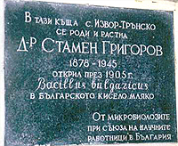
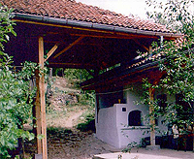
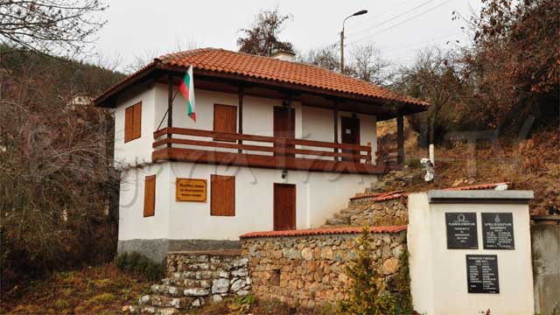
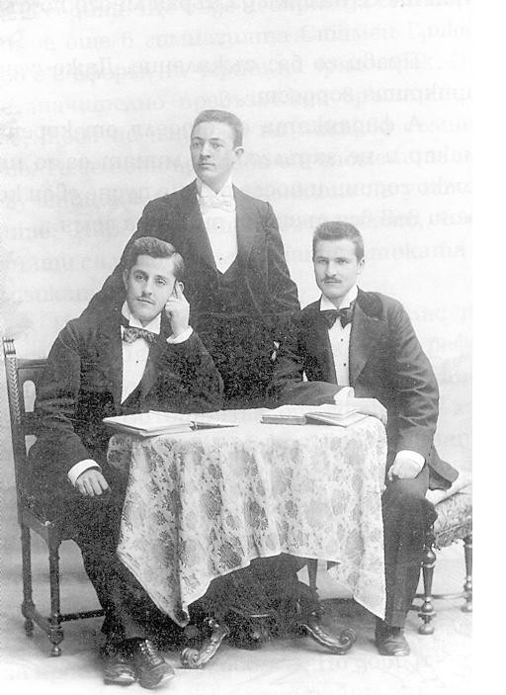
Milk museum

