Guide for Mikołaj Kopernik
Life
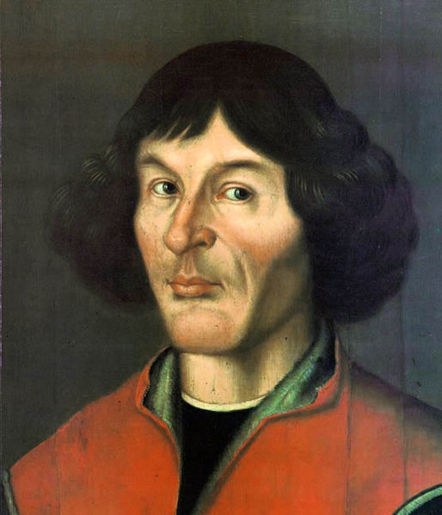
Nicolaus Copernicus was born on 19 February 1473 in the city of Toruń, in the province of Royal Prussia, in the Crown of the Kingdom of Poland. His father was a merchant from Krakow and his mother was the daughter of a wealthy Toruń merchant. Nicolaus was the youngest of four children. His brother Andreas became an Augustinian canon at Frombork. His sister Barbara, named after her mother, became a Benedictine nun and, in her final years, prioress of a convent in Chełmno; she died after 1517. His sister Katharina married the businessman and Toruń city councilor Barthel Gertner and left five children, whom Copernicus looked after to the end of his life.

Portrait, 1580, Toruń Old
Town City Hall

Languages
Copernicus is postulated to have spoken Latin, German, and Polish with equal fluency. He also spoke Greek and Italian. The vast majority of Copernicus’ surviving works are in Latin, which in his lifetime was the language of academia in Europe. Latin was also the official language of the Roman Catholic Church and of Poland's royal court, and thus all of Copernicus’ correspondence with the Church and with Polish leaders was in Latin.
There survive a few documents written by Copernicus in German. The German philosophy professor Martin Carrier mentions this as a reason to consider Copernicus’ native language to have been German. Other arguments for German being Copernicus' native tongue are that he was born in a predominantly German-speaking city and that, while studying canon law at Bologna in 1496, he signed into the German natio (Natio Germanorum)—a student organization which, according to its 1497 by-laws, was open to students of all kingdoms and states whose mother-tongue ("Muttersprache") was German.[26] However, according to French philosopher Alexandre Koyré, Copernicus' registration with the Natio Germanorum does not in itself imply that Copernicus considered himself German, since students from Prussia and Silesia were routinely so categorized, which carried certain privileges that made it a natural choice for German-speaking students, regardless of their ethnicity or self-identification.
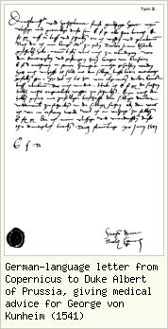
Name
In Copernicus' time, people were often called after the places where they lived. Like the Silesian village that inspired it, Copernicus' surname has been spelled variously. The surname likely had something to do with the local Silesian copper-mining industry, though some scholars assert that it may have been inspired by the dill plant (in Polish, "koperek" or "kopernik") that grows wild in Silesia.
As was to be the case with William Shakespeare a century later, numerous spelling variants of the name are documented for the astronomer and his relatives. The name first appeared as a place name in Silesia in the 13th century, where it was spelled variously in Latin documents. Copernicus "was rather indifferent about orthography". During his childhood, about 1480, the name of his father (and thus of the future astronomer) was recorded in Thorn as Niclas Koppernigk. At Kraków he signed himself, in Latin, Nicolaus Nicolai de Torunia (Nicolaus, son of Nicolaus, of Toruń). At Bologna, in 1496, he registered in the Matricula Nobilissimi Germanorum Collegii, resp. Annales Clarissimae Nacionis Germanorum, of the Natio Germanica Bononiae, as Dominus Nicolaus Kopperlingk de Thorn – IX grosseti. At Padua he signed himself "Nicolaus Copernik", later "Coppernicus". The astronomer thus Latinized his name to Coppernicus, generally with two "p"s (in 23 of 31 documents studied), but later in life he used a single "p". On the title page of De revolutionibus, Rheticus published the name as (in the genitive, or possessive, case) "Nicolai Copernici".
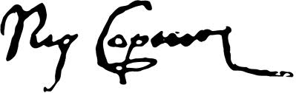

Education

In Poland
Upon the father’s death, young Nicolaus’ maternal uncle, Lucas Watzenrode the Younger (1447–1512), took the boy under his wing and saw to his education and career. Watzenrode maintained contacts with leading intellectual figures in Poland and was a friend of the influential Italian-born humanist and Kraków courtier, Filippo Buonaccorsi. There are no surviving primary documents on the early years of Copernicus' childhood and education. Copernicus biographers assume that Watzenrode first sent young Copernicus to St. John's School, at Toruń, where he himself had been a master. Later, according to Armitage, the boy attended the Cathedral School at Włocławek, up the Vistula River from Toruń, which prepared pupils for entrance to the University of Kraków, Watzenrode's alma mater in Poland's capital.
In the winter semester of 1491–92 Copernicus, as "Nicolaus Nicolai de Thuronia", matriculated together with his brother Andrew at the University of Kraków (now Jagiellonian University). Copernicus began his studies in the Department of Arts (from the fall of 1491, presumably until the summer or fall of 1495) in the heyday of the Kraków astronomical-mathematical school, acquiring the foundations for his subsequent mathematical achievements. According to a later but credible tradition (Jan Brożek), Copernicus was a pupil of Albert Brudzewski, who by then (from 1491) was a professor of Aristotelian philosophy but taught astronomy privately outside the university; Copernicus became familiar with Brudzewski's widely read commentary to Georg von Peuerbach's Theoricæ novæ planetarum and almost certainly attended the lectures of Bernard of Biskupie and Wojciech Krypa of Szamotuły, and probably other astronomical lectures by Jan of Głogów, Michał of Wrocław (Breslau), Wojciech of Pniewy, and Marcin Bylica of Olkusz.
Copernicus' Kraków studies gave him a thorough grounding in the mathematical-astronomical knowledge taught at the university (arithmetic, geometry, geometric optics, cosmography, theoretical and computational astronomy), a good knowledge of the philosophical and natural-science writings of Aristotle (De coelo, Metaphysics), stimulated his interest in learning, and made him conversant with humanistic culture. Copernicus broadened the knowledge that he took from the university lecture halls with independent reading of books that he acquired during his Kraków years (Euclid, Haly Abenragel, the Alfonsine Tables, Johannes Regiomontanus' Tabulae directionum); to this period, probably, also date his earliest scientific notes, now preserved partly at Uppsala University. At Kraków Copernicus began collecting a large library on astronomy; it would later be carried off as war booty by the Swedes during the Deluge in 1650s and is now at the Uppsala University Library.
Copernicus' four years at Kraków played an important role in the development of his critical faculties and initiated his analysis of the logical contradictions in the two most popular systems of astronomy—Aristotle's theory of homocentric spheres, and Ptolemy's mechanism of eccentrics and epicycles—the surmounting and discarding of which constituted the first step toward the creation of Copernicus' own doctrine of the structure of the universe.
Without taking a degree, probably in the fall of 1495, Copernicus left Kraków for the court of his uncle Watzenrode, who in 1489 had been elevated to Prince-Bishop of Warmia and soon (before November 1495) sought to place his nephew in the Warmia canonry vacated by the 26 August 1495 death of its previous tenant, Jan Czanow. For unclear reasons—probably due to opposition from part of the chapter, who appealed to Rome—Copernicus' installation was delayed, inclining Watzenrode to send both his nephews to study canon law in Italy, seemingly with a view to furthering their ecclesiastic careers and thereby also strengthening his own influence in the Warmia chapter.
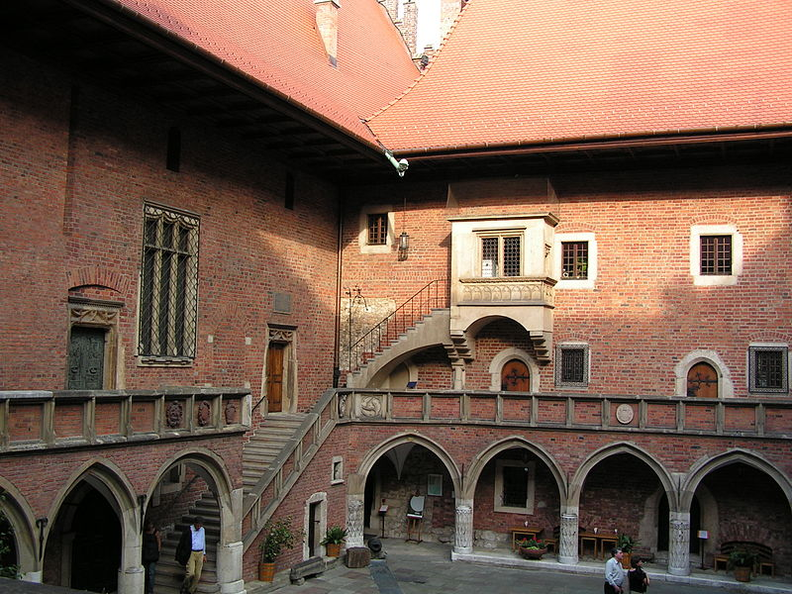
Leaving Warmia in mid-1496—possibly with the retinue of the chapter's chancellor, Jerzy Pranghe, who was going to Italy—in the fall (October?) of that year Copernicus arrived in Bologna and a few months later (after 6 January 1497) signed himself into the register of the Bologna University of Jurists' "German nation", which also included young Poles from Silesia, Prussia and Pomerania, as well as students of other nationalities.

Collegium Maius,
Kraków

In Italy
It was only on 20 October 1497 that Copernicus, by proxy, formally succeeded to the Warmia canonry which had been granted to him two years earlier. To this, by a document dated 10 January 1503 at Padua, he would add a sinecure at the Collegiate Church of the Holy Cross in Wrocław, Silesia, Bohemia. Despite having been granted a papal indult on 29 November 1508 to receive further benefices, through his ecclesiastic career Copernicus not only did not acquire further prebends and higher stations at the chapter, but in 1538 he relinquished the Wrocław sinecure. It is uncertain whether he was ordained a priest; he may only have taken minor orders, which sufficed for assuming a chapter canonry.
During his three-year stay at Bologna, between fall 1496 and spring 1501, Copernicus seems to have devoted himself less keenly to studying canon law (he received his doctorate in law only after seven years, following a second return to Italy in 1503) than to studying the humanities—probably attending lectures by Filippo Beroaldo, Antonio Urceo, called Codro, Giovanni Garzoni, and Alessandro Achillini—and to studying astronomy. He met the famous astronomer Domenico Maria Novara da Ferrara and became his disciple and assistant. Copernicus was developing new ideas inspired by reading the "Epitome of the Almagest" (Epitome in Almagestum Ptolemei) by George von Peuerbach and Johannes Regiomontanus (Venice, 1496). He verified its observations about certain peculiarities in Ptolemy's theory of the Moon's motion, by conducting on 9 March 1497 at Bologna a memorable observation of Aldebaran, the brightest star in the Taurus constellation, whose results reinforced his doubts as to the geocentric system. Copernicus the humanist sought confirmation for his growing doubts through close reading of Greek and Latin authors (Pythagoras, Aristarchos of Samos, Cleomedes, Cicero, Pliny the Elder, Plutarch, Philolaus, Heraclides, Ecphantos, Plato), gathering, especially while at Padua, fragmentary historic information about ancient astronomical, cosmological and calendar systems.
Copernicus spent the jubilee year 1500 in Rome, where he arrived with his brother Andrew that spring, doubtless to perform an apprenticeship at the Papal Curia. Here, too, however, he continued his astronomical work begun at Bologna, observing, for example, a lunar eclipse on the night of 5–6 November 1500. According to a later account by Rheticus, Copernicus also—probably privately, rather than at the Roman Sapienza—as a "Professor Mathematum" (professor of astronomy) delivered, "to numerous... students and... leading masters of the science", public lectures devoted probably to a critique of the mathematical solutions of contemporary astronomy.
On his return journey doubtless stopping briefly at Bologna, in mid-1501 Copernicus arrived back in Warmia. After on 28 July receiving from the chapter a two-year extension of leave in order to study medicine (since "he may in future be a useful medical advisor to our Reverend Superior [Bishop Lucas Watzenrode] and the gentlemen of the chapter"), in late summer or in the fall he returned again to Italy, probably accompanied by his brother Andrew and by Canon B. Sculteti. This time he studied at the University of Padua, famous as a seat of medical learning, and—except for a brief visit to Ferrara in May–June 1503 to pass examinations for, and receive, his doctorate in canon law—he remained at Padua from fall 1501 to summer 1503.[43]
Copernicus studied medicine probably under the direction of leading Padua professors—Bartolomeo da Montagnana, Girolamo Fracastoro, Gabriele Zerbi, Alessandro Benedetti—and read medical treatises that he acquired at this time, by Valescus de Taranta, Jan Mesue, Hugo Senensis, Jan Ketham, Arnold de Villa Nova, and Michele Savonarola, which would form the embryo of his later medical library.
One of the subjects that Copernicus must have studied was astrology, since it was considered an important part of a medical education. However, unlike most other prominent Renaissance astronomers, he appears never to have practiced or expressed any interest in astrology.
As at Bologna, Copernicus did not limit himself to his official studies. It was probably the Padua years that saw the beginning of his Hellenistic interests. He familiarized himself with Greek language and culture with the aid of Theodorus Gaza's grammar (1495) and J.B. Chrestonius' dictionary (1499), expanding his studies of antiquity, begun at Bologna, to the writings of Basilius Bessarion, Lorenzo Valla and others. There also seems to be evidence that it was during his Padua stay that the idea finally crystallized, of basing a new system of the world on the movement of the Earth.
As the time approached for Copernicus to return home, in spring 1503 he journeyed to Ferrara where, on 31 May 1503, having passed the obligatory examinations, he was granted the degree of doctor of canon law. No doubt it was soon after (at latest, in fall 1503) that he left Italy for good to return to Warmia.

Nicolaus Copernicus Monument in Kraków
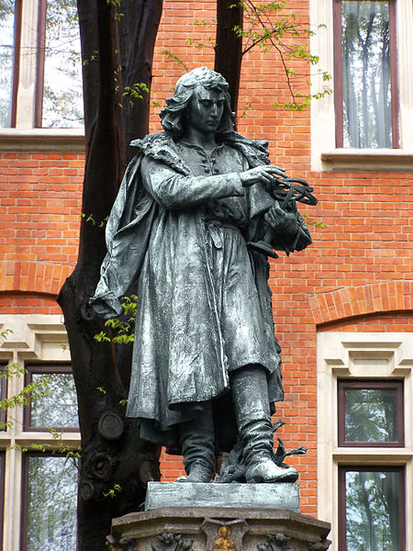

Work

Having completed all his studies in Italy, 30-year-old Copernicus returned to Warmia, where he would live out the remaining 40 years of his life, apart from brief journeys to Kraków and to nearby Prussian cities: Toruń, Gdańsk, Elbląg, Grudziądz, Malbork, Königsberg.

The Prince-Bishopric of Warmia enjoyed substantial autonomy, with its own diet (parliament) and monetary unit (the same as in the other parts of Royal Prussia) and treasury.

Copernicus was his uncle's secretary and physician from 1503 to 1510 (or perhaps till his uncle's death on 29 March 1512) and resided in the Bishop's castle at Lidzbark (Heilsberg), where he began work on his heliocentric theory. In his official capacity, he took part in nearly all his uncle's political, ecclesiastic and administrative-economic duties. From the beginning of 1504, Copernicus accompanied Watzenrode to sessions of the Royal Prussian diet held at Malbork and Elbląg and, write Dobrzycki and Hajdukiewicz, "participated... in all the more important events in the complex diplomatic game that ambitious politician and statesman played in defense of the particular interests of Prussia and Warmia, between hostility to the Order and loyalty to the Polish Crown." In 1504–12 Copernicus made numerous journeys as part of his uncle's retinue—in 1504, to Toruń and Danzig, to a session of the Royal Prussian Council in the presence of Poland's King Alexander Jagiellon; to sessions of the Prussian diet at Malbork (1506), Elbląg (1507) and Sztum (1512); and he may have attended a Poznań session (1510) and the coronation of Poland's King Sigismund I the Old in Kraków (1507). Watzenrode's itinerary suggests that in spring 1509 Copernicus may have attended the Kraków sejm. It was probably on the latter occasion, in Kraków, that Copernicus submitted for printing at Jan Haller's press his translation, from Greek to Latin, of a collection, by the 7th-century Byzantine historian Theophylact Simocatta, of 85 brief poems called Epistles, or letters, supposed to have passed between various characters in a Greek story. They are of three kinds—"moral," offering advice on how people should live; "pastoral", giving little pictures of shepherd life; and "amorous", comprising love poems. They are arranged to follow one another in a regular rotation of subjects. Copernicus had translated the Greek verses into Latin prose, and he now published his version as Theophilacti scolastici Simocati epistolae morales, rurales et amatoriae interpretatione latina, which he dedicated to his uncle in gratitude for all the benefits he had received from him. With this translation, Copernicus declared himself on the side of the humanists in the struggle over the question whether Greek literature should be revived. Copernicus' first poetic work was a Greek epigram, composed probably during a visit to Kraków, for Johannes Dantiscus' epithalamium for Barbara Zapolya's 1512 wedding to King Zygmunt I the Old.

Some time before 1514, Copernicus wrote an initial outline of his heliocentric theory known only from later transcripts, by the title (perhaps given to it by a copyist), Nicolai Copernici de hypothesibus motuum coelestium a se constitutis commentariolus—commonly referred to as the Commentariolus. It was a succinct theoretical description of the world's heliocentric mechanism, without mathematical apparatus, and differed in some important details of geometric construction from De revolutionibus; but it was already based on the same assumptions regarding Earth's triple motions. The Commentariolus, which Copernicus consciously saw as merely a first sketch for his planned book, was not intended for printed distribution. He made only a very few manuscript copies available to his closest acquaintances, including, it seems, several Kraków astronomers with whom he collaborated in 1515–30 in observing eclipses. Tycho Brahe would include a fragment from the Commentariolus in his own treatise, Astronomiae instauratae progymnasmata, published in Prague in 1602, based on a manuscript that he had received from the Bohemian physician and astronomer Tadeáš Hájek, a friend of Rheticus. The Commentariolus would appear complete in print for the first time only in 1878. In 1510 or 1512 Copernicus moved to Frombork, a town to the northwest at the Vistula Lagoon on the Baltic Sea coast. There, in April 1512, he participated in the election of Fabian of Lossainen as Prince-Bishop of Warmia. It was only in early June 1512 that the chapter gave Copernicus an "external curia"—a house outside the defensive walls of the cathedral mount. In 1514 he purchased the northwestern tower within the walls of the Frombork stronghold. He would maintain both these residences to the end of his life, despite the devastation of the chapter's buildings by a raid against Frauenburg carried out by the Teutonic Order in January 1520, during which Copernicus' astronomical instruments were probably destroyed. Copernicus conducted astronomical observations in 1513–16 presumably from his external curia; and in 1522–43, from an unidentified "small tower", using primitive instruments modeled on ancient ones—the quadrant, triquetrum, armillary sphere. At Frombork Copernicus conducted over half of his more than 60 registered astronomical observations.

Having settled permanently at Frombork, where he would reside to the end of his life, with interruptions in 1516–19 and 1520–21, Copernicus found himself at the Warmia chapter's economic and administrative center, which was also one of Warmia's two chief centers of political life. In the difficult, politically complex situation of Warmia, threatened externally by the Teutonic Order's aggressions (attacks by Teutonic bands; the Polish-Teutonic War of 1519–21; Albert's plans to annex Warmia), internally subject to strong separatist pressures (the selection of the prince-bishops of Warmia; currency reform), he, together with part of the chapter, represented a program of strict cooperation with the Polish Crown and demonstrated in all his public activities (the defense of his country against the Order's plans of conquest; proposals to unify its monetary system with the Polish Crown's; support for Poland's interests in the Warmia dominion's ecclesiastic administration) that he was consciously a citizen of the Polish-Lithuanian Republic. Soon after the death of uncle Bishop Watzenrode, he participated in the signing of the Second Treaty of Piotrków Trybunalski (7 December 1512), governing the appointment of the Bishop of Warmia, declaring, despite opposition from part of the chapter, for loyal cooperation with the Polish Crown.

That same year (before 8 November 1512) Copernicus assumed responsibility, as magister pistoriae, for administering the chapter's economic enterprises (he would hold this office again in 1530), having already since 1511 fulfilled the duties of chancellor and visitor of the chapter's estates.

His administrative and economic dutes did not distract Copernicus, in 1512–15, from intensive observational activity. The results of his observations of Mars and Saturn in this period, and especially a series of four observations of the Sun made in 1515, led to discovery of the variability of Earth's eccentricity and of the movement of the solar apogee in relation to the fixed stars, which in 1515–19 prompted his first revisions of certain assumptions of his system. Some of the observations that he made in this period may have had a connection with a proposed reform of the Julian calendar made in the first half of 1513 at the request of the Bishop of Fossombrone, Paul of Middelburg. Their contacts in this matter in the period of the Fifth Lateran Council were later memorialized in a complimentary mention in Copernicus' dedicatory epistle in De revolutionibus orbium coelestium and in a treatise by Paul of Middelburg, Secundum compendium correctionis Calendarii (1516), which mentions Copernicus among the learned men who had sent the Council proposals for the calendar's emendation. During 1516–21, Copernicus resided at Olsztyn Castle as economic administrator of Warmia, including Olsztyn and Pieniężno. While there, he wrote a manuscript, Locationes mansorum desertorum, with a view to populating those fiefs with industrious farmers and so bolstering the economy of Warmia. When Olsztyn was besieged by the Teutonic Knights during the Polish–Teutonic War (1519–21), Copernicus directed the defense of Olsztyn and Warmia by Royal Polish forces. He also represented the Polish side in the ensuing peace negotiations.

Copernicus for years advised the Royal Prussian sejmik on monetary reform, particularly in the 1520s when that was a major question in regional Prussian politics. In 1526 he wrote a study on the value of money, Monetae cudendae ratio. In it he formulated an early iteration of the theory, now called Gresham's Law, that "bad" coinage drives "good" (un-debased) coinage out of circulation—several decades before Thomas Gresham. He also, in 1517, set down a quantity theory of money, a principal concept in economics to the present day. Copernicus' recommendations on monetary reform were widely read by leaders of both Prussia and Poland in their attempts to stabilize currency. In 1533, Johann Widmanstetter, secretary to Pope Clement VII, explained Copernicus' heliocentric system to the Pope and two cardinals. The Pope was so pleased that he gave Widmanstetter a valuable gift. In 1535 Bernard Wapowski wrote a letter to a gentleman in Vienna, urging him to publish an enclosed almanac, which he claimed had been written by Copernicus. This is the only mention of a Copernicus almanac in the historical records. The "almanac" was likely Copernicus' tables of planetary positions. Wapowski's letter mentions Copernicus' theory about the motions of the earth. Nothing came of Wapowski's request, because he died a couple of weeks later.

Following the death of Prince-Bishop of Warmia Mauritius Ferber (1 July 1537), Copernicus participated in the election of his successor, Johannes Dantiscus (20 September 1537). Copernicus was one of four candidates for the post, written in at the initiative of Tiedemann Giese; but his candidacy was actually pro forma, since Dantiscus had earlier been named coadjutor bishop to Ferber. At first Copernicus maintained friendly relations with the new Prince-Bishop, assisting him medically in spring 1538 and accompanying him that summer on an inspection tour of Chapter holdings. But that autumn, their friendship was strained by suspicions over Copernicus' housekeeper, Anna Schilling, whom Dantiscus removed from Frombork in 1539. In his younger days, Copernicus the physician had treated his uncle, brother and other chapter members. In later years he was called upon to attend the elderly bishops who in turn occupied the see of Warmia—Mauritius Ferber and Johannes Dantiscus — and, in 1539, his old friend Tiedemann Giese, Bishop of Chełmno (Kulm). In treating such important patients, he sometimes sought consultations from other physicians, including the physician to Duke Albert and, by letter, the Polish Royal Physician.

In the spring of 1541, Duke Albert summoned Copernicus to Königsberg to attend the Duke's counselor, George von Kunheim, who had fallen seriously ill, and for whom the Prussian doctors seemed unable to do anything. Copernicus went willingly; he had met von Kunheim during negotiations over reform of the coinage. And Copernicus had come to feel that Albert himself was not such a bad person; the two had many intellectual interests in common. The Chapter readily gave Copernicus permission to go, as it wished to remain on good terms with the Duke, despite his Lutheran faith. In about a month the patient recovered, and Copernicus returned to Frombork. For a time, he continued to receive reports on von Kunheim's condition, and to send him medical advice by letter. Throughout this period of his life, Copernicus continued making astronomical observations and calculations, but only as his other responsibilities permitted and never in a professional capacity.[citation needed]

Some of Copernicus' close friends turned Protestant, but Copernicus never showed a tendency in that direction. The first attacks on him came from Protestants. Wilhelm Gnapheus, a Dutch refugee settled in Elbląg, wrote a comedy in Latin, Morosophus (The Foolish Sage), and staged it at the Latin school that he had established there. In the play, Copernicus was caricatured as a haughty, cold, aloof man who dabbled in astrology, considered himself inspired by God, and was rumored to have written a large work that was moldering in a chest.

Elsewhere Protestants were the first to react to news of Copernicus' theory. Melanchthon wrote:

Some people believe that it is excellent and correct to work out a thing as absurd as did that Sarmatian astronomer who moves the earth and stops the sun. Indeed, wise rulers should have curbed such light-mindedness.

Nevertheless, in 1551, eight years after Copernicus' death, astronomer Erasmus Reinhold published, under the sponsorship of Copernicus' former military adversary, the Protestant Duke Albert, the Prussian Tables, a set of astronomical tables based on Copernicus' work. Astronomers and astrologers quickly adopted it in place of its predecessors.

The book

Copernicus was still working on De revolutionibus orbium coelestium (even if not certain that he wanted to publish it) when in 1539 Georg Joachim Rheticus, a Wittenberg mathematician, arrived in Frombork. Philipp Melanchthon, a close theological ally of Martin Luther, had arranged for Rheticus to visit several astronomers and study with them. Rheticus became Copernicus' pupil, staying with him for two years and writing a book, Narratio prima (First Account), outlining the essence of Copernicus' theory. In 1542 Rheticus published a treatise on trigonometry by Copernicus (later included in the second book of De revolutionibus).

Under strong pressure from Rheticus, and having seen the favorable first general reception of his work, Copernicus finally agreed to give De revolutionibus to his close friend, Tiedemann Giese, bishop of Chełmno (Kulm), to be delivered to Rheticus for printing by the German printer Johannes Petreius at Nuremberg (Nürnberg), Germany. While Rheticus initially supervised the printing, he had to leave Nuremberg before it was completed, and he handed over the task of supervising the rest of the printing to a Lutheran theologian, Andreas Osiander.

Osiander added an unauthorised and unsigned preface, defending the work against those who might be offended by the novel hypotheses. He explained that astronomers may find different causes for observed motions, and choose whatever is easier to grasp. As long as a hypothesis allows reliable computation, it does not have to match what a philosopher might seek as the truth.
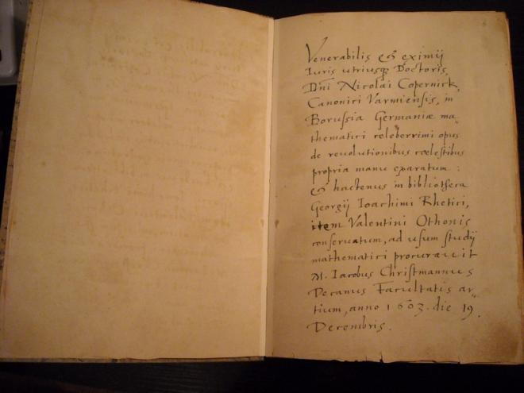
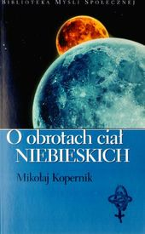

"On the Revolutions of the
heavenly bodies"

Death

Toward the close of 1542, Copernicus was seized with apoplexy and paralysis, and he died at age 70 on 24 May 1543. Legend has it that he was presented with an advance copy of his De revolutionibus orbium coelestium on the very day that he died, allowing him to take farewell of his life's work. He is reputed to have awoken from a stroke-induced coma, looked at his book, and then died peacefully.

Copernicus was reportedly buried in Frombork Cathedral, where archaeologists for over two centuries searched in vain for his remains. Efforts to locate the remains in 1802, 1909, 1939 and 2004 had come to nought. In August 2005, however, a team led by Jerzy Gąssowski, head of an archaeology and anthropology institute in Pułtusk, after scanning beneath the cathedral floor, discovered what they believed to be Copernicus' remains.

The find came after a year of searching, and the discovery was announced only after further research, on 3 November 2008. Gąssowski said he was "almost 100 percent sure it is Copernicus". Forensic expert Capt. Dariusz Zajdel of the Polish Police Central Forensic Laboratory used the skull to reconstruct a face that closely resembled the features—including a broken nose and a scar above the left eye—on a Copernicus self-portrait. The expert also determined that the skull belonged to a man who had died around age 70—Copernicus' age at the time of his death.

The grave was in poor condition, and not all the remains of the skeleton were found; missing, among other things, was the lower jaw. The DNA from the bones found in the grave matched hair samples taken from a book owned by Copernicus which was kept at the library of the University of Uppsala in Sweden.

On 22 May 2010 Copernicus was given a second funeral in a Mass led by Józef Kowalczyk, the former papal nuncio to Poland and newly named Primate of Poland. Copernicus' remains were reburied in the same spot in Frombork Cathedral where part of his skull and other bones had been found. A black granite tombstone now identifies him as the founder of the heliocentric theory and also a church canon. The tombstone bears a representation of Copernicus' model of the solar system—a golden sun encircled by six of the planets.

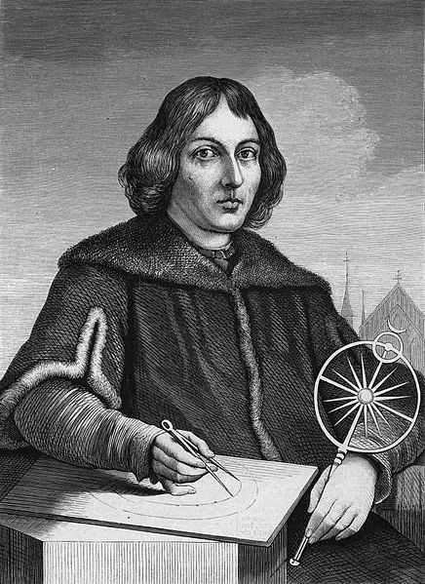

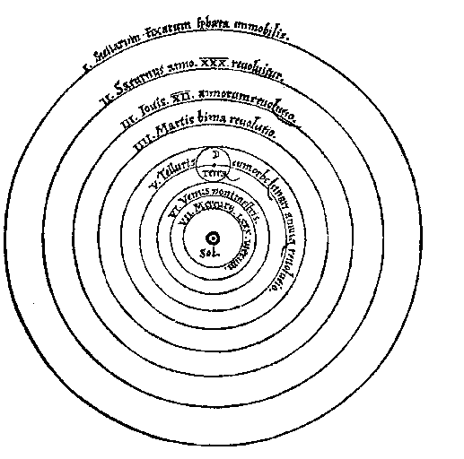

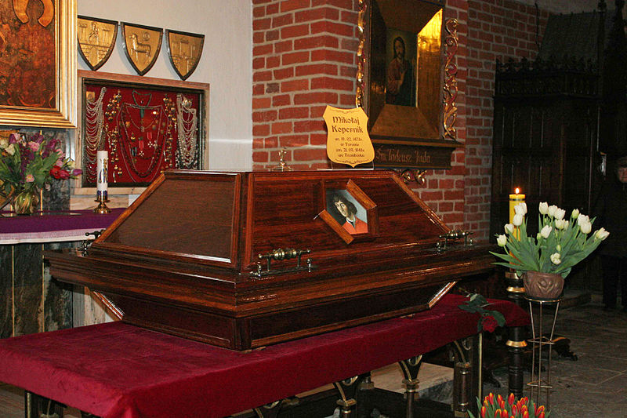

Casket with Copernicus' remains, St. James' Cathedral Basilica, Allenstein, March 2010

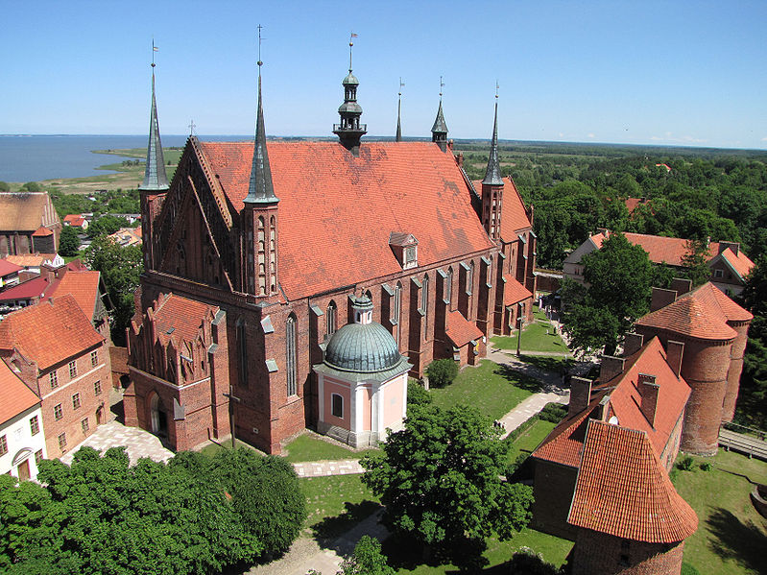

Frombork Cathedral
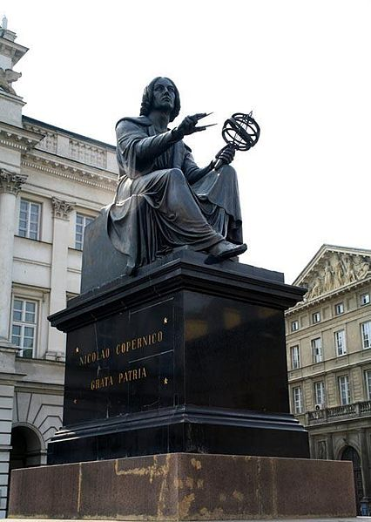
Thorvaldsen's Copernicus Monument in Warsaw

